**EXECUTIVE SUMMARY**

The business is a multistate online retailer that offers clothing and personal items in 51 US states. However, sales dropped overtime and as a result, the analysis is focused on getting back all the consumers the business has lost and seeking out information to help the business expand.

The analysis are as follows:

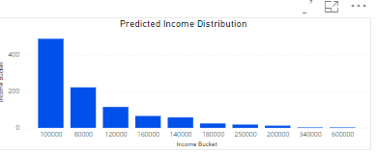

According to the chart, it is predicted that most of the customers earn $100,000 annually.

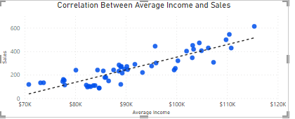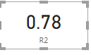

Based on the analysis, there's a direct (strong) correlation between average income and sales. Therefore, sales increases as income increases.

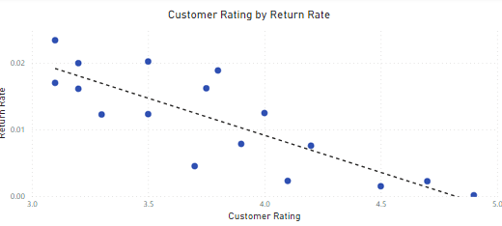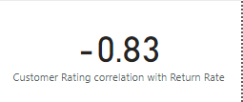

Customer rating and return rate have an indirect indirect relationship, as shown by the scatter plot. Customer satisfaction drops as the rate of product returns rises. Winter gloves had the highest number of returns, which may have been caused by poor quality, high cost compared to competitors, delivery of the incorrect size to clients, etc.

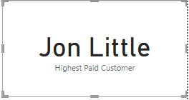

As seen on the visualization card, Jon Little is the highest paid customer and he is from Illinois. However, Illinois isn’t part of the first five states with the highest sales.

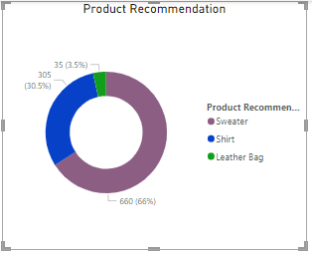

According to the chart, sweater (66%) is the most recommended product based on the predicted income of the customers.

Recommendation:

* Sweater and shirt is recommended to be advertised in all the states, while Leather bag can be advertised to people in District of Columbia, Maryland and
* A survey should be carried out to specific customers that returned product in order to know their reasons for returning the products. More attention should be given to winter gloves
* More adverts should be targeted to states with high income because as seen on the chart, the higher the income, the higher the sales.